**6.5 Nerves, hormones and homeostasis.**

**6.5.1 State that the nervous system consists of the central nervous system (CNS) and peripheral nerves, and is composed of cells called neurons that can carry rapid electrical impulses.(1)**

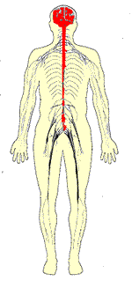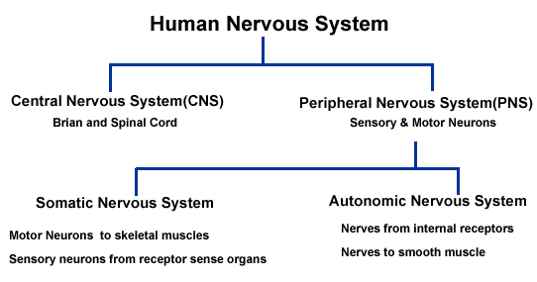

**6.5.2 Draw and label a diagram of the structure of a motor neuron.(1)**

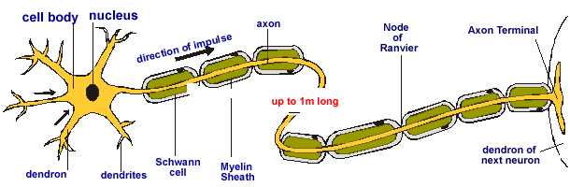[Electron micrograph cross section](http://click4biology.info/c4b/6/motorneuron.htm)

* A neuron has a cell body with extensions leading off it.
* Numerous dendrons and dendrites provide a large surface area for connecting with other neurons, and carry nerve impulses towards the cell body.
* A single long axon carries the nerve impulse away from the cell body.
* The axon is only 10µm in diameter but can be up to 4m in length in a large animal (a piece of spaghetti the same shape would be 400m long)!
* Most neurons have many companion cells called Schwann cells, which wrap their cell membrane around the axon many times in a spiral to form a thick insulating lipid layer called the myelin sheath.
* Nerve impulse can be passed from the axon of one neuron to the dendron of another at a synapse. A nerve is a discrete bundle of several thousand neuron axons.

Humans have three types of neuron:

* Sensory neurons have long axons and transmit nerve impulses from sensory receptors all over the body to the central nervous system.
* Motor neurons also have long axons and transmit nerve impulses from the central nervous system to effectors (muscles and glands) all over the body.
* Interneurones (also called connector neurons or relay neurons) are usually much smaller cells, with many interconnections.

**6.5.3 State that nerve impulses are conducted from receptors to the CNS by sensory neurons, within the CNS by relay neurons, and from the CNS to effectors by motor neurons.(1)**

* There are various receptor 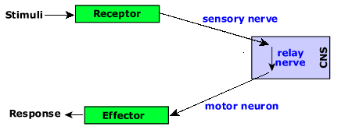around the body such as skin and the eye.
* Stimuli (think of them as energy forms) are detected by the receptors and turned into an nerve impulse (chemical energy).
* Nerve impulses from sensory nerves are conducted to the central nervous system along sensory neurons.
* The impulse is sent to the relay neurons that move it around inside the central nervous system (brain and spine).
* Motor neurons take the relayed nerve impulse to the effectors (often muscles) which then produce the response.

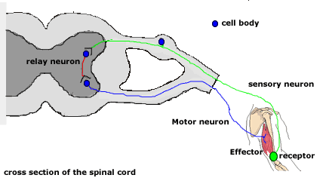

* This is a cross section through the vertebrate spinal column.
* The receptor is deep in the biceps muscle.
* Sensory neuron conducts nerve impulses from the receptor to the central nervous system.
* The relay nerve conducts the impulse through the spinal cord and in a reflex back to the motor neuron.
* The motor neuron connects to the effector which in this case is the biceps muscle.

**6.5.4 Define resting potential and action potential (depolarization and repolarization).(1).**

* 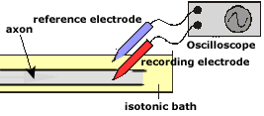To record the electrical activity of a nerve it is placed in an isotonic fluid bath.
* A reference electrode is placed in the surrounding fluid.
* A recording electrode is inserted into the cytoplasm of the axon.
* The electrical disturbances are measured and displayed on the oscilloscope.

**Membrane potentials:**

* **Resting potential**is the negative charge registered when the nerve is at rest and not conducting a nerve impulse.
* **Action potential** is the positive electrochemical charge generated at the nerve impulse. Normally this is seen as the 'marker' of the nerve impulse position.
* **Depolarization** is a change from the negative resting potential to the positive action potential.
* **Re-polarization** is the change in the electrical potential from the positive action potential back to the negative resting potential.

**6.5.5 Explain how a nerve impulse passes along a non-myelinated neuron.(3).**

To understand the Resting Potential and Action Potential first consider an ion pump found in the plasma membrane

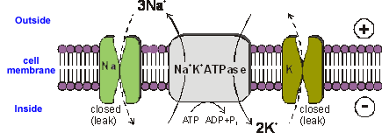

**Sodium-Potassium ATPase**

* This uses the energy from ATP splitting to simultaneously pump 3 sodium ions out of the cell and 2 potassium ions in.
* If this was to continue unchecked there would be no sodium or potassium ions left to pump, but there are also sodium and potassium ion channels in the membrane.
* These channels are normally closed, but even when closed, they “leak”, allowing sodium ions to leak in and potassium ions to leak out, down their respective concentration gradients.
* The combination of the Na +K +ATPase pump and the leak channels cause a stable imbalance of Na + and K + ions across the membrane.
* This imbalance causes a potential difference across all animal cell membranes, called the ***membrane potential***.
* The membrane potential is always negative inside the cell, and varies in size from –20 to –200 mV in different cells and species.
* The Na +K+ ATPase is thought to have evolved as an osmoregulator to keep the internal water potential high and so stop water entering animal cells and bursting them. Plant cells don’t need this as they have strong cells walls to prevent bursting.

**Resting Potential & Action Potential**

* In nerve and muscle cells the membranes are electrically excitable, which means that they can change their membrane potential, and this is the basis of the nerve impulse.
* The sodium and potassium channels in these cells are ***voltage-gated***, which means that they can open and close depending on the voltage across the membrane.
* Early experiments on nerves focused on the non-myelinated ***Squid Giant Axon*** .
* An electrodes is placed inside the cell and one outside the cell (reference).
* The electrodes are attached to an oscilloscope
* The nerve cell is stimulated to generate a nerve impulse and the voltage change recorded on the oscilloscope.

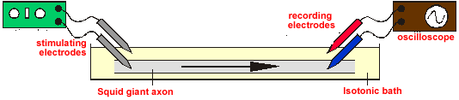

* The normal membrane potential of these nerve cells is –70mV (inside the axon), and since this potential can change in nerve cells it is called the **resting potential.**
* When a stimulating pulse was applied a brief reversal of the membrane potential, lasting about a millisecond, was recorded. This brief reversal is called the **action potential:**

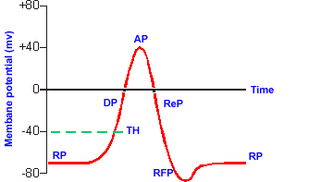RP: **Resting Potential**

DP: Depolarisation

AP: Action Potential

ReP: Re-polarisation

RFP: Refractory Period

TH: Threshold

The Action Potential has two stages depolarization (**DP**) and Re-polarization(**ReP**)

**Depolarization** (**DP**)

* 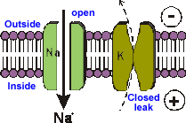The stimulating electrodes cause the membrane potential to change a little.
* The voltage-gated ion channels can detect this change, and when the potential reaches –30mV**(TH)** the sodium channels open for 0.5ms
* The causes sodium ions to rush in, making the inside of the cell more positive.
* This phase is referred to as a depolarization since the normal voltage polarity (negative inside) is reversed (becomes positive inside).

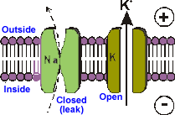

**Re-polarization** (**ReP**).

* The membrane potential reaches 0V.
* The potassium channels open for 0.5ms, causing potassium ions to rush out.
* This makes the inside more negative again.
* Since this restores the original polarity, it is called re-polarization

**How the nerve impulse travels along the axon:**

* Once an action potential has started it is moved (propagated) along an axon automatically.
* The local reversal of the membrane potential is detected by the surrounding voltage-gated ion channels, which open when the potential

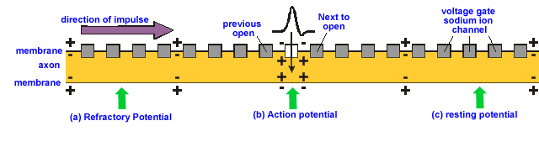

**Section a) Refractory potential:**

The axon is in a refractory (**ReP**) period which means that diffusion backwards of Na+ from the action potential is not able to depolarize the membrane channels. This means the impulse travels in one direction

**Section b) Action Potential:**

The voltage gates have been opened and there is a high concentration of Na+ in the axon. This diffuses to the next set of voltage gates depolarising from resting potential.

**Section c: Resting potential:**

The Na+will diffuse to this position. If the voltage reaches threshold (**TH**) then the channel will open Na+will flood in and a new action potential site will be established.

**Threshold (TH):**

* The ion channels are either open or closed; there is no half-way position. This means that the action potential always reaches +40mV as it moves along an axon, and it is never attenuated (reduced) by long axons. In other word the action potential is all-or-nothing.

**Re factory Period (ReP)**:

* After an ion channel has opened, it needs a “rest period” before it can open again.
* This is called the refractory period, and lasts about 2 ms.
* This means that, although the action potential affects all other ion channels nearby, the upstream ion channels cannot open again since they are in their refractory period, so only the downstream channels open, causing the action potential to move one-way along the axon.
* The delay caused by refractory period also prevents the summation of Action potentials (one impulse cannot catch up another impulse)

**Human Nerve propagation:**

It should be noted that the description given above of nerve conduction is for a squid giant axon. This is a typical arrangement in the invertebrates. To increase the rate of nerve conduction the axon diameter is increased. However, vertebrates have a different method of accelerating their nerve conduction but this is not part of the IB syllabus for this particular unit. You can however read about this method of nerve conduction called [saltatory conduction](http://click4biology.info/c4b/6/saltatory%20conduction.htm).

**6.5.6 Explain the principles of synaptic transmission.(3)**

* The junction between two neurons is called a synapse.
* An action potential cannot cross the synaptic cleft between neurons, and instead the nerve impulse is carried by chemicals called neurotransmitters.
* These chemicals are made by the cell that is sending the impulse (the pre-synaptic neuron) and stored in synaptic vesicles at the end of the axon.
* The cell that is receiving the nerve impulse (the post-synaptic neuron) has chemical-gated ion channels in its membrane, called neuroreceptors.
* These have specific binding sites for the neurotransmitters

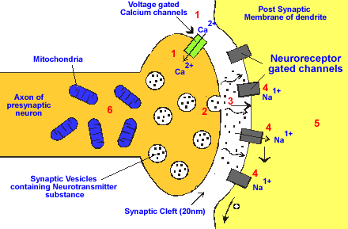1. At the end of the pre-synaptic neuron there are voltage-gated calcium channels. When an action potential reaches the synapse these channels open, causing calcium ions to flow into the cell.

2. These calcium ions cause the synaptic vesicles to fuse with the cell membrane, releasing their contents (the neurotransmitter chemicals) by exocytosis.

3. The neurotransmitters diffuse across the synaptic cleft.

4. The neurotransmitter binds to the neuroreceptors in the post-synaptic membrane, causing the channels to open. In the example shown these are sodium channels, so sodium ions flow in.

5. This causes a depolarisation of the post-synaptic cell membrane, which may initiate an action potential.

6. The neurotransmitter is broken down by a specific enzyme in the synaptic cleft; for example the enzyme acetylcholinesterase breaks down the neurotransmitter acetylcholine. The breakdown products are absorbed by the pre-synaptic neuron by endocytosis and used to re-synthesis more neurotransmitter, using energy from the mitochondria. This stops the synapse being permanently on.

**6.5.7 State that the endocrine system consists of glands that release hormones that are transported in the blood.(1)**

* 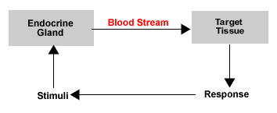The gland secretes these hormones into the blood stream
* The hormone travels in blood to the target tissue (effector) that brings about a response.
* The response modifies the internal environment and this becomes feedback stimuli

**6.5.8 State that homeostasis involves maintaining the internal environment between limits, including blood pH, carbon dioxide concentration, blood glucose concentration, body temperature and water balance.(1)**

Homeostasis involves maintaining the internal environment (tissue fluid, blood) between limits.

Examples:

* Blood pH
* Blood carbon dioxide levels
* blood glucose concentration
* body temperature
* water balance

**6.5.9 Explain that homeostasis involves monitoring levels of variables and correcting changes in levels by negative feedback mechanisms.(3)**

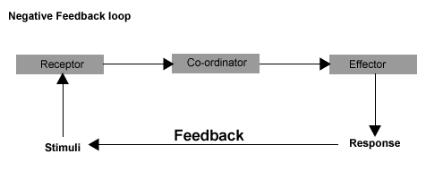

* This model represents the main features of a negative feedback model.
* Specialized receptors detect changes within the internal conditions
* This information is relayed to a central coordinator that determines the level of response
* The coordinator in turn relays such a decision to the effector that is specialized to produce the response behavior
* Notice that this response will modify the internal environment and that these new conditions will in turn become the new stimuli.
* The cycle will continue until conditions are reduced back to within narrow acceptable limits (fixed regulation point).
* Notice that system works responding to conditions which are lower than and higher than the fixed regulation point.
* Very efficient systems allow very little in the way of undershoot and overshoot.

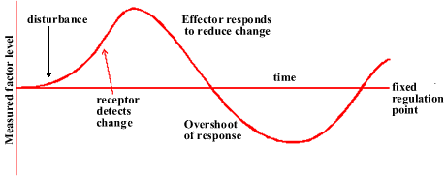

This model is an alternative representation of the negative feedback cycle but this time emphasising the deviation from a fixed regulation point.

**6.5.10 Explain the control of body temperature, including the transfer of heat in blood, and the roles of the hypothalamus, sweat glands, skin arterioles and shivering.(3).**

The control of body temperature includes the transfer of heat in blood, the role of sweat glands and skin arterioles, and shivering.

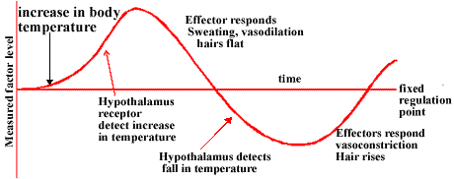

Model of temperature control:

* The sensors are found in the hypothalamus.
* Effectors are found in the skin and in muscles.
* The fixed point for regulation is around 37.8 degrees centigrade.

Note the particular features of skin which are 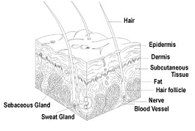involved in temperature regulation:

* Hairs with the erector Pilli muscle
* Sweat glands
* Blood arterioles
* The skin is an effector in the control of body temperature.
* It is particularly important to prevent cooling or overheating of the core (essential organs and brain)

**The hypothalamus as the co-ordinator of temperature regulation:**

**Vasoconstriction**: is a cold adaptation narrowing of arterioles that reduces blood flow to the surface of the skin is coupled with a dilation of the horizontal shunt vessels. This prevents heat loss from blood near the skin surface and retains heat in the body core for essential organs.

**Vasodilation**: is an adaptation to warm conditions in which arterioles dilate sending more blood closer to the skin surface from where heat can be radiated to the surrounding environment. The horizontal shunt vessels are constricted sending most blood closer to the skin surface. Additionally sweat (mainly water) is released onto the surface of the skin where it enters the vapour phase when warmed by the heat carried by blood. Therefore the vapour of sweat carried away heat energy from blood.

**Cold:** when cold the following events occur 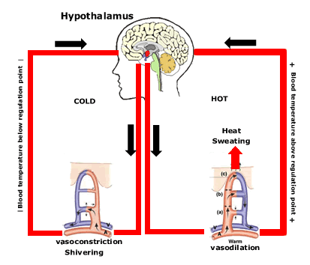to reduce heat loss and raise temperature.

Lower than regulation temperature blood reaches the hypothalamus.

The hypothalamus signals the vasoconstriction (narrowing) of arterioles

Muscle effectors are produces the rapid contraction relaxation of muscles known as shivering which produces more body heat.

**Hot:**

* Sweat is secreted onto the surface of skin when body temperature is high
* Sweat is largely composed of water which has a high specific heat capacity (absorbs a heat easily)
* Body heat is transferred from skin and blood to the sweat
* The sweat evaporates transferring heat away and in doing so cools the body

Hair and temperature control:

* In warm weather the erector-pilli muscle are relaxed and the hairs lie flat.
* This prevents a build up of a 'boundary layer' of warm air.
* Air movement will further accelerate the loss of heat.
* In cold weather the erector-pilli muscle contracts and the hair moves vertical. This traps a 'boundary layer' of warm air that reduces the temperature gradient and in turn reduces heat loss.
* Other longer term adaptations take place when exposed to continuously high or low temperatures. These effects are often linked to the metabolic rate of the organism and are atleast in part influenced by the endocrine system.
* Whilst a significant mechanism for the control of heat loss in many mammals the relatively hairless body of humans derives very little benefit from this mechanism.

**6.5.11 Explain the control of blood glucose concentration, including the roles of glucagon, insulin and α and β cells in  
the pancreatic islets.(3)**

Blood sugar concentration is regulated for a number of reason amongst which:

Osmosis. content of a tissue is determined by the concentration of the surrounding tissues.

Respiration: Some tissues are entirely dependent on blood sugar as a respiratory substrate being unable to either store glucose of metabolize fat.

Model:

a) Low glucose concentration is 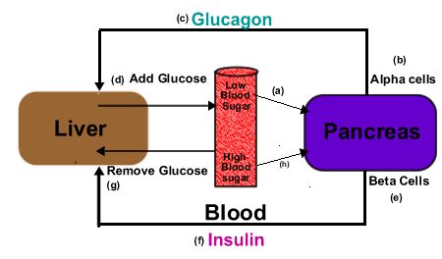detected by the pancreas.

b) Alpha cells in the pancreatic islets secret glucagon.

c)Glucagon flows through the blood to receptors on liver cells.

d)Liver responds by adding glucose to blood stream.

h) High blood glucose levels stimulate the beta pancreatic cells

a) Beta pancreatic cells secrete insulin.

f)Insulin flows through the blood to the receptors on liver cells.

g)Insulin stimulates the liver to remove blood glucose and store this as glycogen (insoluble)

Blood sugar regulation alternative diagram (labels correspond to both diagrams)

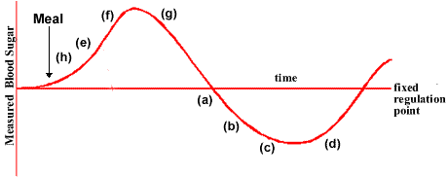Note from the second diagram that the glucose levels remain within a set of narrow limits. The regulation point for blood glucose is around 5 mmol dm-3.

The response and change in blood glucose levels becomes the new stimuli for receptors

This is a typical feedback control.

Additional features of blood sugar regulation:

* Insulin stimulates the 'glucose-transporter molecules' in the cell membrane of liver cells to take up glucose.
* Insulin is responsible for the conversion of glucose to glycogen but also to fat.
* Insulin stimulates the incorporation of 'glucose-transporter molecules into the cell membrane of the muscle cells. Then the glucose is taken up and stored as glycogen as in the liver. Muscles will store around 900g of glycogen in comparison to the average 100 g in the liver.
* Adipose (fat cells) are also stimulated to take up the glucose and begin its conversion to fat.
* Almost all cells are influenced in this way by insulin, except that is for the cells of the nervous system which require a constant blood glucose level.
* After the absorption of glucose most cells will switch their metabolism to the beta oxidation of fat and preserve their glycogen stores. This cannot be done by the cells of the nervous system which of course is another reason to maintain blood sugar levels.

Ask around your class for people who whilst not diabetics experience mild hyperglycaemia or have experienced this as on the odd occasion. They will describe that if they do not eat regularly that they experience muscle weakness, lethargy, mild visual disturbance. The interesting features are those that affect their nervous system and have some remarkable resemblance to mild migraine symptoms.

**6.5.12 Distinguish between type I and type II diabetes. (2)**

**Type I diabetes (early or juvenile onset):**

* Auto-immune disease in which the beta-cells pancreatic are destroyed.
* Unable to produce insulin.
* Responds well to regular injection of insulin probably manufactured as the genetically engineered *humulin.*

**Type II diabetes (Adult onset):**

* Reduced sensitivity of the liver cells to insulin.
* Reduced number of receptors on the liver cell membrane.

In both types of diabetes there is:

* a build of glucose in the blood stream and it will then subsequently appear in urine.(test with a *Clinistic* )
* High concentrations of blood glucose (hyperglycaemia) results in the movement of water from cells by osmosis.
* This extra fluid in the blood results in larger quantities of urine production.
* A lack of glucose in cells means that fats then proteins have to be metabolized in respiration.
* Particularly the breakdown of protein for energy creates organ damage.